The role of remote Photoplethysmography in Musical Biofeedback Systems for Stress Reduction and Consciousness Regulation

Structure

- Introduction
- Stress
- Remote Photoplethysmography
- Musical Biofeedback
- Regeneration and Consciousness Regulation
- Case Studies
- Conclusion

Introduction

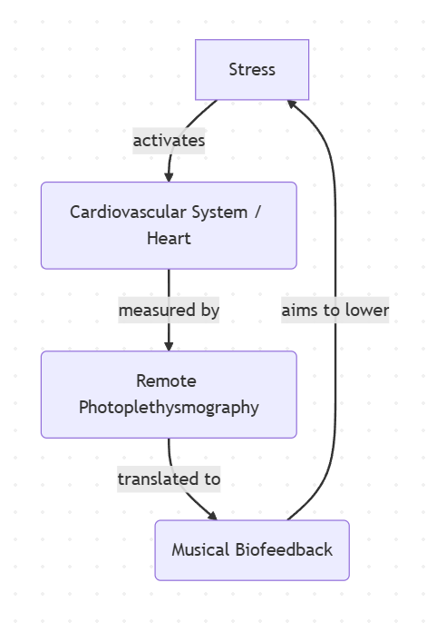
Stress
Stress -> protective response of the body
Harmless situations trigger stress -> harmful habits
Heart rate -> quantity of heart activity
Heart rate variability -> represents the quality of heart activity

Remote Photoplethysmography (foundation)
It measures optical changes on the skin surface
Blood contains absorbs specific wavelengths of light-> especially green light
Heartbeat effect -> every heartbeat blood is pumped into the facial tissue -> changes the blood volume rhythmically
More blood = more absorbtion -> when blood volume increases, more green light is absorbed
Green channel hast he highest information about the pulse signal
Target Area: cheeks -> easily accessible, exposed

Remote Photoplethysmography (Signal extraction overview)
Problem -> measurement always contains noise -> light and movement
Blind source separation -> statistical independence isolate noise
Physics based Models (CHROM) -> skin-light-reflection properties
Deep Learning models -> neural networks trained with lots of data

Remote Photoplethysmography (Blind Source Separation)
Camera Image is a mixture of (Pulse, Light, Motion)
Mathematical algorithms are usd to separate the signals

Filtering -> Bandpass > Restrict Data to 45-240BPM
Fast Fourier Transform -> find the heart beat
Outlier Rejection -> unrealistic jumps

Limitation -> Component Misidentifiation -> in extreme motion the wrong signal might be choosen
Long data window 30s

Remote Photoplethysmography (CHROM)
Camera sees:¹
Intensity: Brightness of light
Specular Reflection: Mirror-like glare on the surface
Static Skin Color: The constant tissue color
All noise vectors move along the axis of the standard skin tone vector
Chrom projects the signals onto a 2d that is perpendicular to this skin tone vector

Noise cancellation: Looking from this 90-degreen angle flattens the noise to a single point
- Noise is cancelled out leaving a clean movement robust pulse signal
Bandpass Filter -> matching the human heart rate (42-240BPM)
Fast Fourier Transform -> identifies the strongest periodic signal
The "Motion" Advantage: Maintains a 48% success rate under heavy movement – where BSS models drop to a failing 4-11%¹
Low latency: Only 1.6s (vs 30s with BSS)
Diversity: Robust performance across all skin tones¹

Remote Photoplethysmography (Deep Learning Models)
Transition to End-to-End Deep Learning Models¹
Fully automated: No manual Face/ROI selection required¹
Data challenges:¹
Significant lack of large-scale, high-quality datasets
Underrepresentation of diverse age groups and skin pigmentations
Mobile Optimization: Ongoing research into lightweight models for real-time deployment on smartphone hardware¹

Musical Biofeedback
Data-to-music transformation

Heartbeat data is directly and fluidly mapped to musical elements like (pitch, tempo, volume) without any delay
To make the feedback intuitive -> natural real world associations
Heart rate decreases -> volume gets lower or the pitch decreases
User instinctively understand their physiological changes
Uses natural associations (e.g. distance) to represent intensity

Regeneration and Consciousness Regulation
Cardiovascular Sychronization: user breathes at about 6 breaths per minute -> resonance frequency is reached
Heart rate and blood pressure synchronize perfectly -> reduces strain on the cardiovascular system, optimizes gas exchange in the lungs
Triggers a deep relaxation response -> music acts as a meditative anchor keeping the user focus
Mindfulness: By listening closely to their internal states -> user develops more openness and curiosity towards their thouhgs, learning to perceive their emotions without judgement

Case Studies (Unwind System)
Concept: Nature soundscapes with sedative music to guide relaxation¹
HRV Sonification¹:
Wind Mapping: Heart Rate Variability (HRV) is mapped to wind sounds
Users adapt their breathing to transform the wind into a smooth, consistent sine wave
Adaptive Soundscape¹:
LOW HRV (Stress): Environment becomes busy and complex
High HRV (Relaxed): Soundscape becomes simple, transparent and calm
Key Results:¹
Significant reduction in both heart rate and respiration rate in comparison to the control group
70% of participants used the nature sounds to visualize scenes, significantly improving focus and immersion.

Case Studies (MuseTM Headband )
The concept: Lowering the entry barrier for meditation through real-time brainwave measurement¹
Daily attention training with feedback through smartphone app¹

Key Findings:¹
Stress Reduction: The experimental group recorded a 7% decrease after 2 weeks and 14% after 4 weeks
Mental Performance: Improved concentration levels and superior impulse control during complex tasks
Control Group: Showed no significant changes in stress or performance levels
Real-time feedback is the decisive factor¹

Conclusion
The Core Metric: Heart Rate Variability (HRV)¹
HRV provides significantly deeper physiological insights than simple Heart Rate (BPM)
Technical Strategy: ²
Choosing CHROM for its computational efficiency and real-time capabilities
The Competitive Edge:
Unlike Blind Source Separation³, CHROM requires shorter observation windows and effectively identifies the correct color channels ²
Superior to Deep Learning: CHROM is robust against noise without the massive resource intensity or dataset bias of AI models⁴

The mapping Process¹:
Continuous Mapping: instant, fluid audio stream
Sound Design: Calm State = Calm Sound – non intrusive soundscapes to reinforce relaxation
Evidence-Based Systems:
Unwind System: uses nature sounds for feedback²
Muse™: uses real-time loops to increase stress awareness and control³

Future Outlook
Potential: Monitor stress at work (office)
Trend: Small AI models for laptops or mobiles
Efficiency: Cost-effective (simple camera)
Privacy: High risk! Local processing only (No Cloud)

